**MaterialRouter**

**https://github.com/Madevil/MaterialRouter/releases**

Function:

1.Make a material_clone(now replaced by copy material in ME3)

2.Seperate material of clothes if it can shift.

3.Seperate material of body parts if it is separable.

功能:

1.創造複數的material(現在已被ME3的copy material所取代)

2.分離出著衣及半脫狀態的material

3.分離出臉及身體上可分離物件(如左右眼瞳孔)的material

Example 範例:

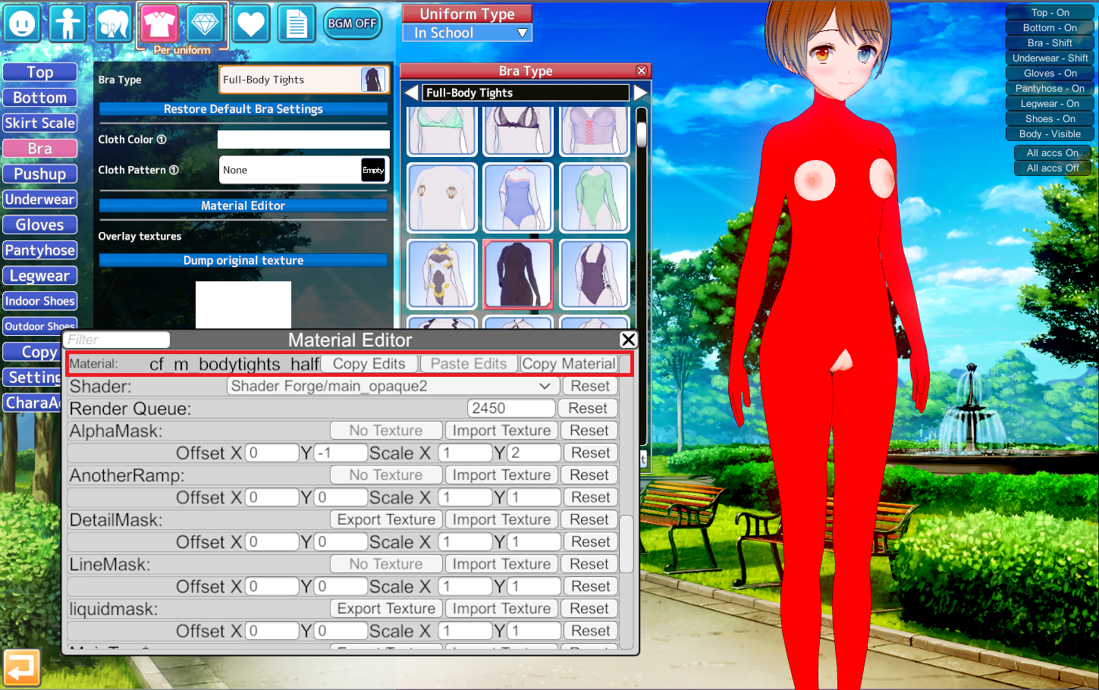

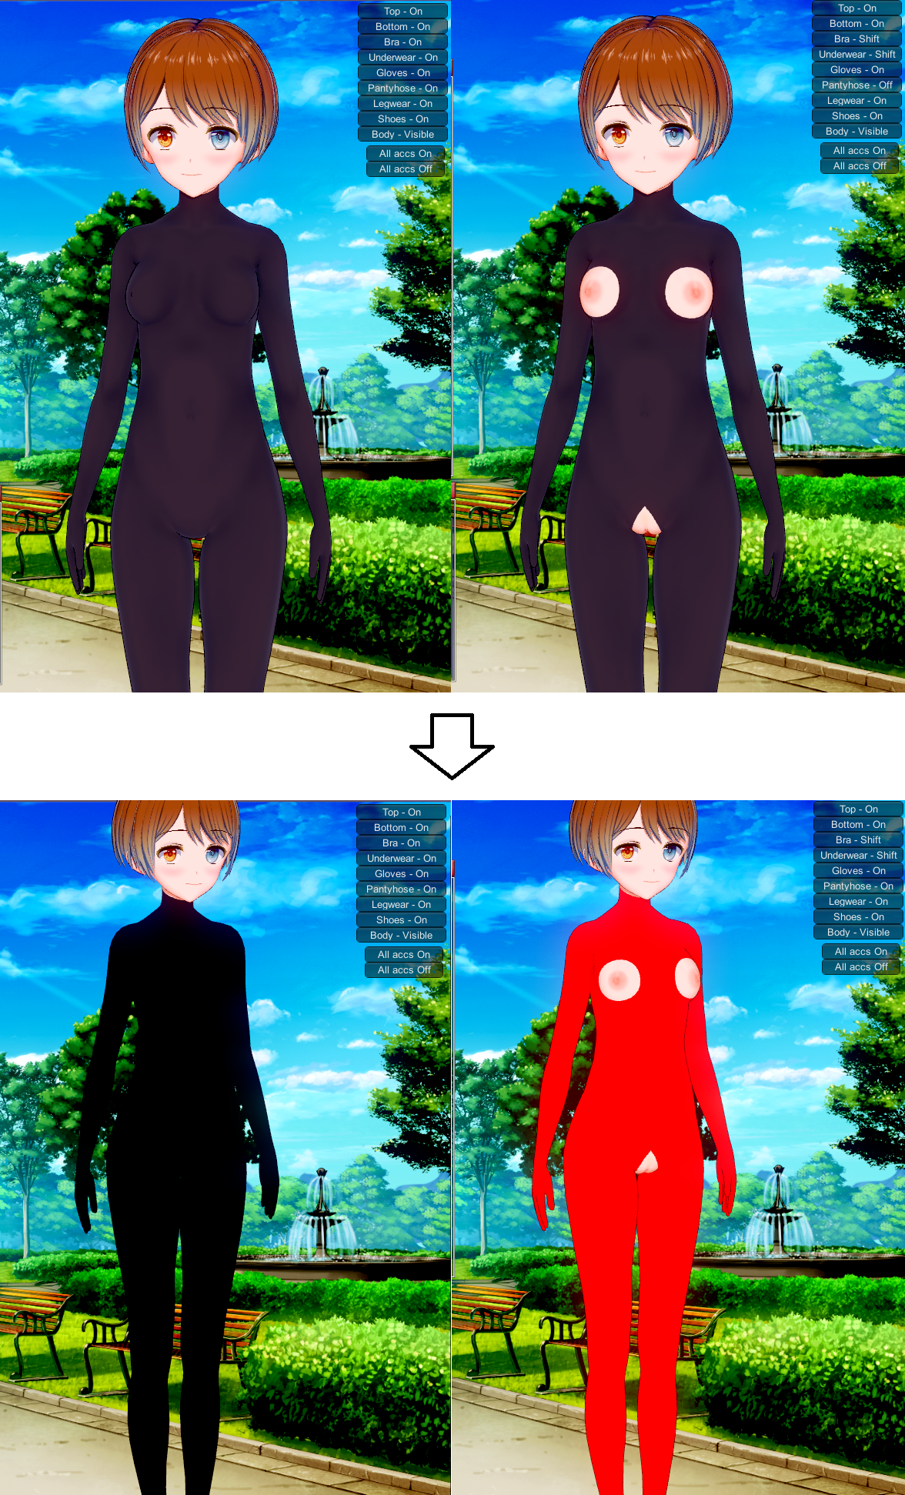

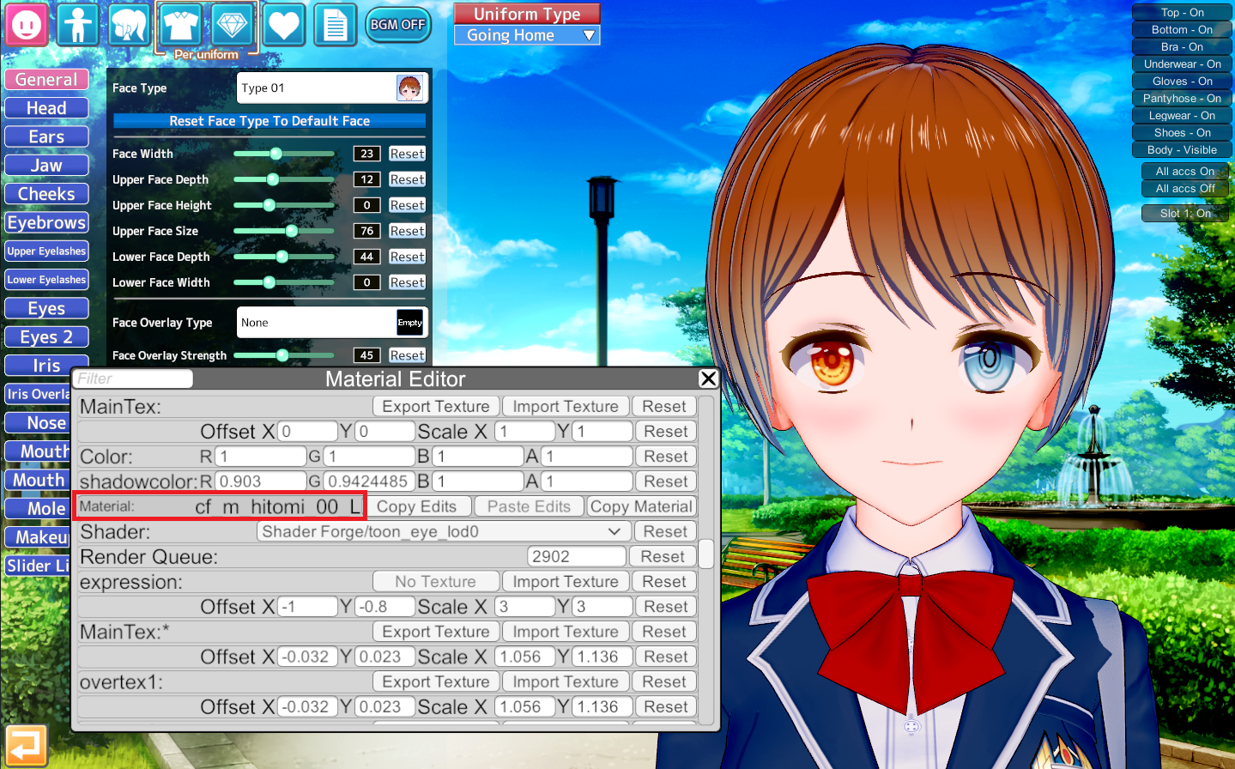

**Install**

Put MaterialRouter.dll in **BepInEx\plugins** in your game folder.

將MaterialRouter.dll 放進遊戲資料夾中的**BepInEx\plugins**.

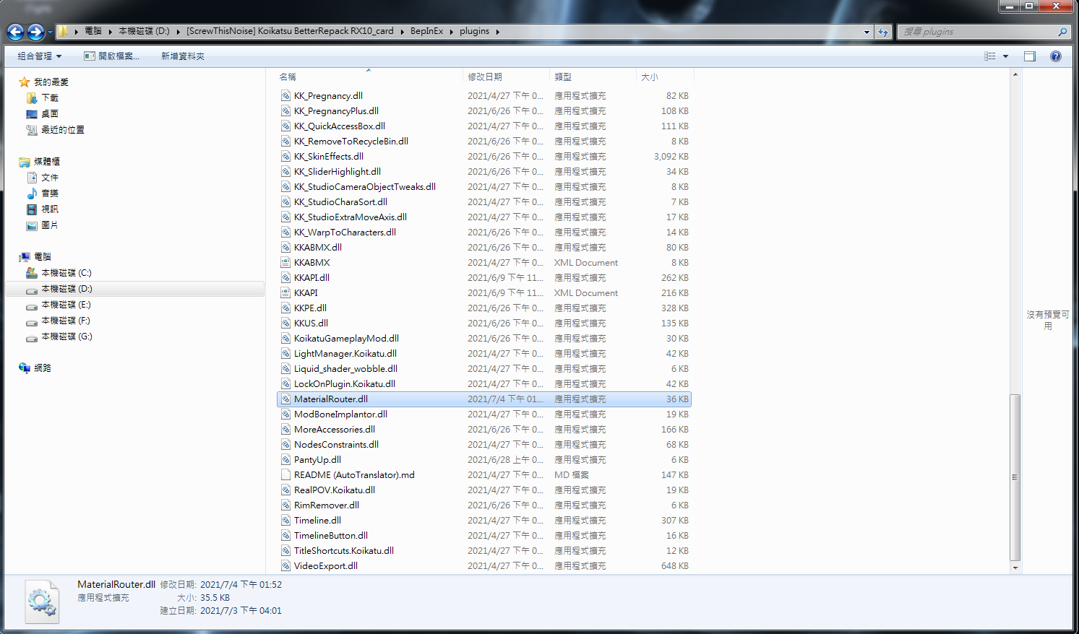

Open game with **Activate Console**

勾選**Activate Console**並打開遊戲

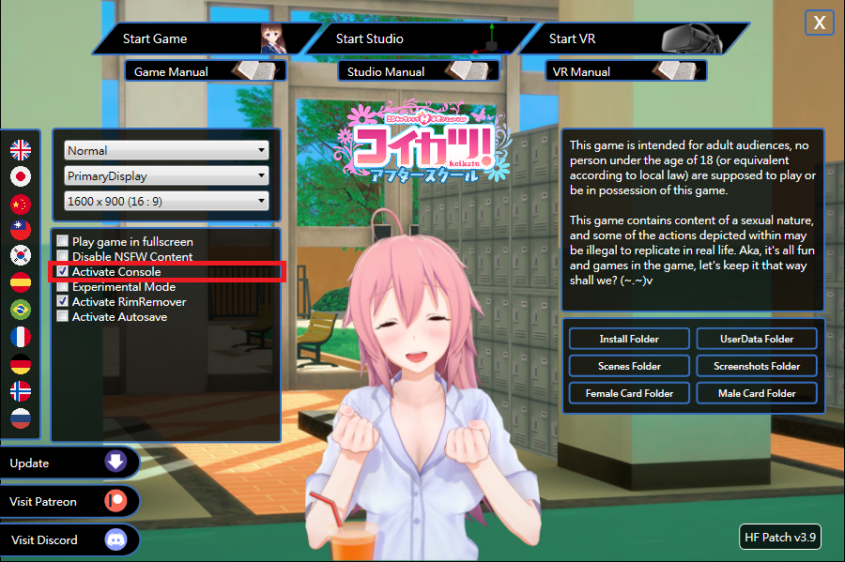

In Game, you will find a new function named **Router** added.

在遊戲中, 你會發現一個名叫**Router**的功能增加了.

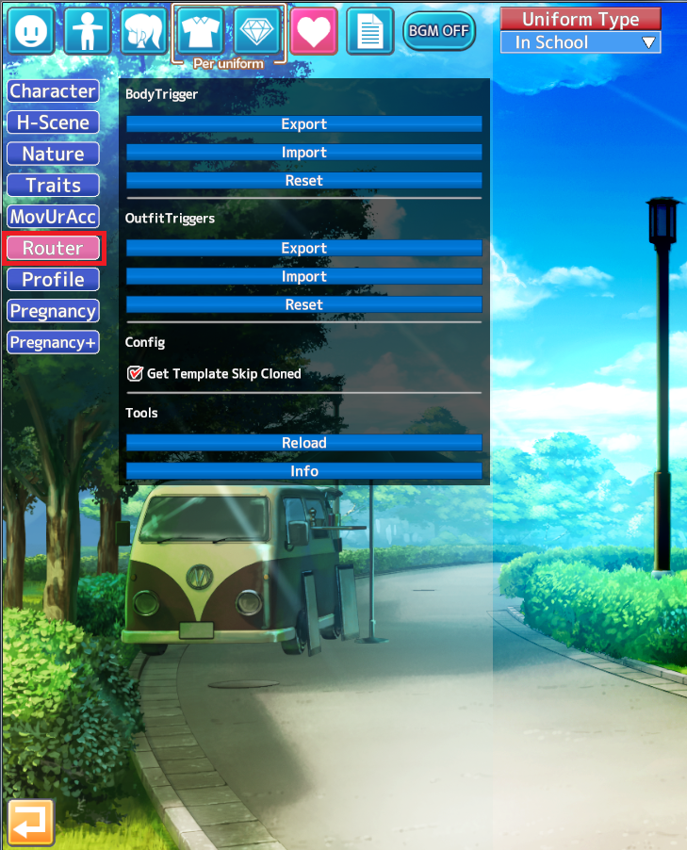

**Part1.Clothes**

To the clothes menu, Full-body Tights for example, click the **Console Output** button**.**

If nothing outputs, update KKAPI.

https://github.com/IllusionMods/IllusionModdingAPI/releases

要分離衣服material的話,到衣服界面,以全身緊身衣為例,點擊叫**Console Output**的按鈕

假如沒出現黃字,需更新KKAPI

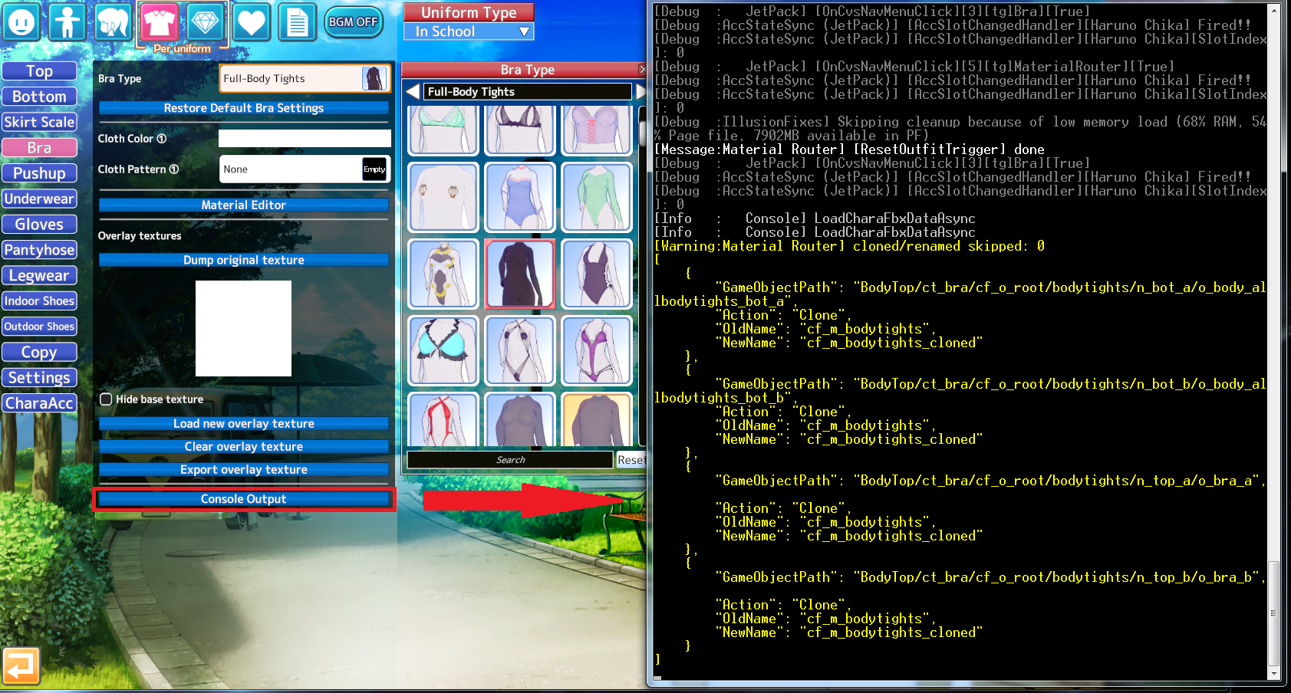

Open **MaterialRouterOutfit** with **JSON Editor.**

用**JSON**編輯器**MaterialRouterOutfit**

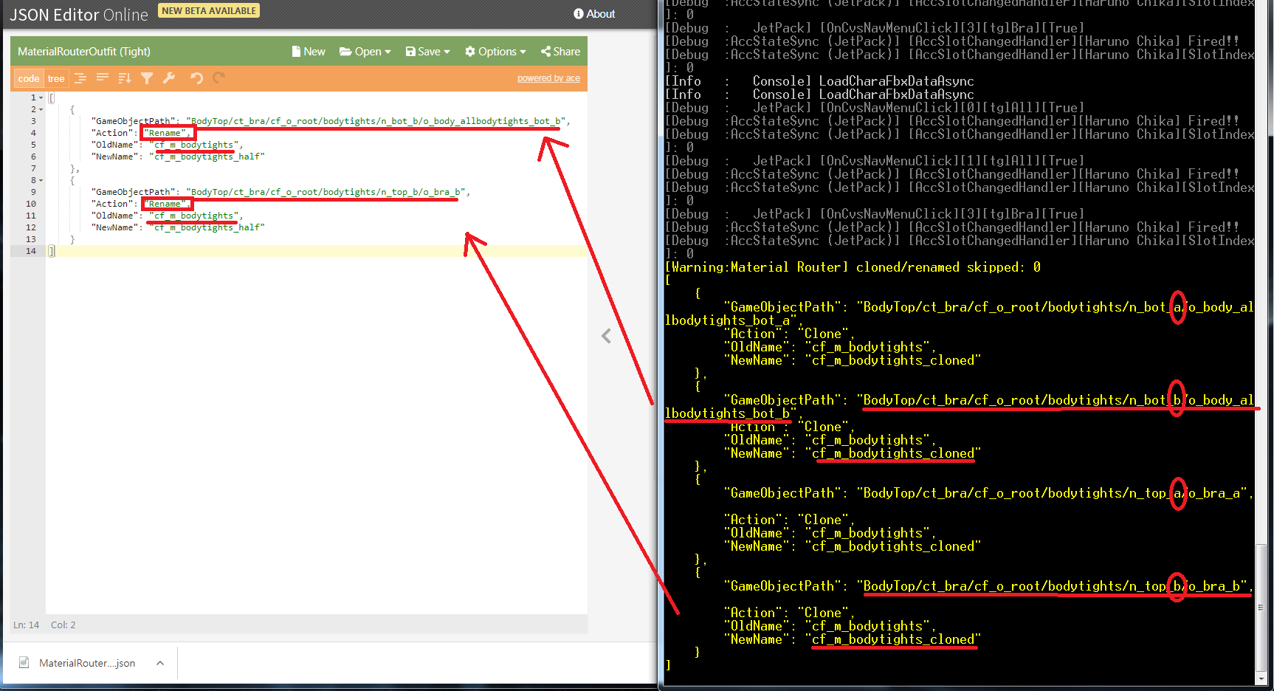

Recognize which GameObject is shifted_clothes. (Mainly **b** or **half** in Path or file name)

Copy the path and object names into the json file.

The “Oldname” should be as same as the object name in console.

Change the “Newname” to a different name.

The “Action” should be “Rename”

Then save it and put it into the “Temp” folder in your game folder (You can create one if you don’t have one.)

Make sure the json file still named”**MaterialRouterOutfit**”

Import it by **Router** in game.

分辨出哪一物件是半脫後的衣服 (通常是有**b** 或 **half** 出現在路徑或檔名中的)

將路徑和檔名複製到json檔當中

"Oldname” 要和console中有同樣的名子.

將“Newname”命名為不同的名子.

“Action”之後必須是“Rename”

存檔並將json檔放入在遊戲資料夾中的名為“Temp”資料夾(假如沒有可以自己新增一個)

確保json檔名為”**MaterialRouterOutfit**”

用**Router**進行匯入(**Import**)

Use **Reload** in **Router.**

You will find new material in ME.

用**Router**中的**Reload**重新讀取

你將會發現有一個新的material在ME中

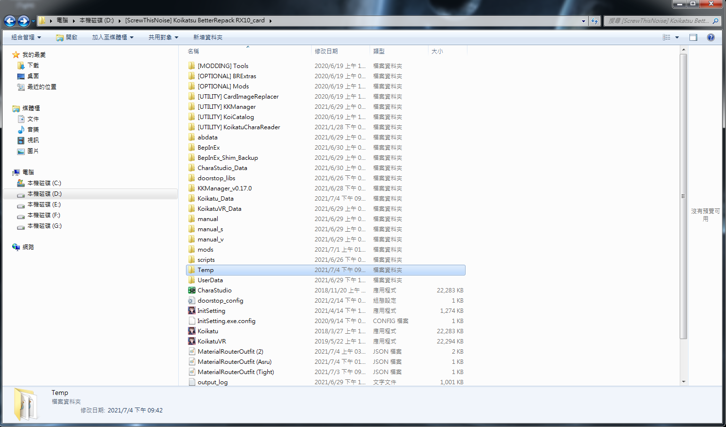

**Part2.Body**

To the face menu, left Iris for example, click the **Head Get Template** button.

If nothing outputs, update KKAPI.

https://github.com/IllusionMods/IllusionModdingAPI/releases

要分離身體物件material的話,到臉的介面,以左瞳孔為例.點擊叫**Head Get Template**的按鈕

假如沒出現黃字,需更新KKAPI

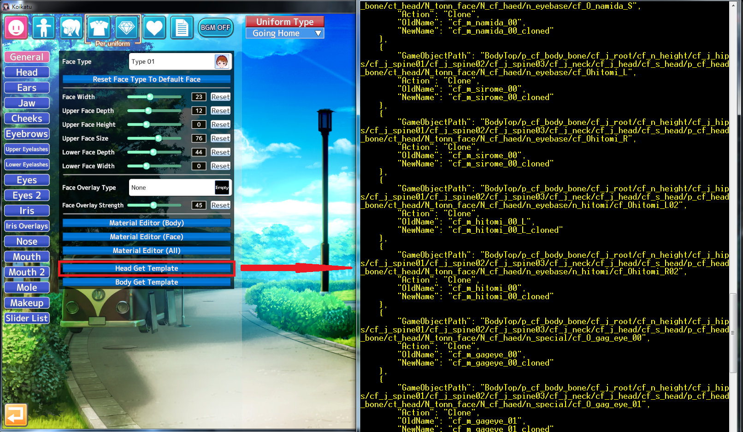

Open **MaterialRouterBody** with **JSON Editor.**

用**JSON**編輯器**MaterialRouterBody**

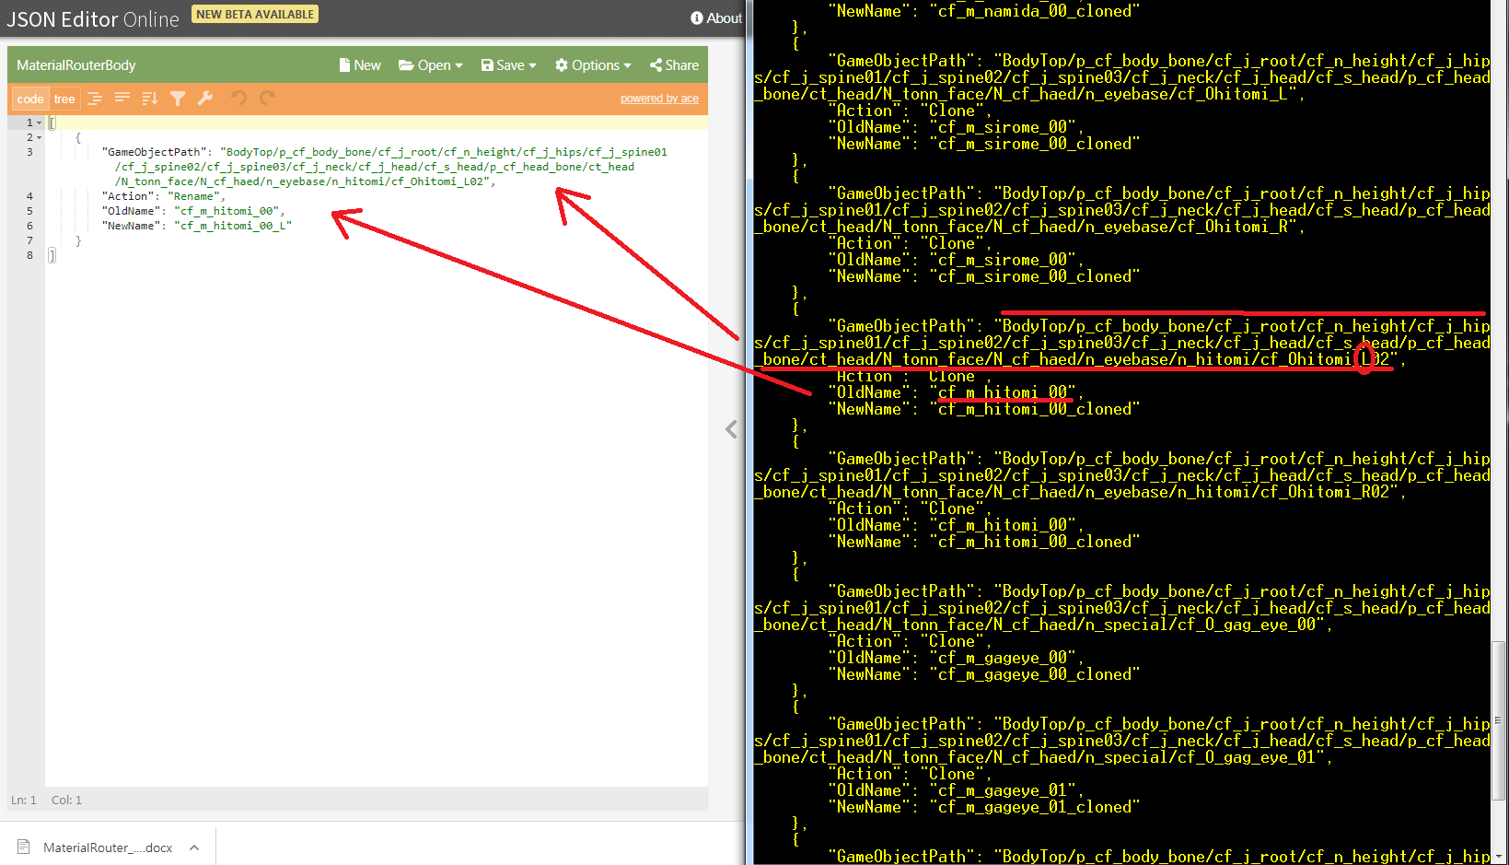

Recognize which GameObject is left iris. (with **L** and **hitomi** in Path and file name)

Copy the path and object names into the json file.

The “Oldname” should be as same as the object name in console.

Change the “Newname” to a different name.

The “Action” should be “Rename”

Then save it and put it into the “Temp” folder in your game folder (You can create one if you don’t have one.)

Make sure the json file still named”**MaterialRouterBody**”

**Import** it by **Router** in game.

分辨出哪一物件是左瞳孔 (有hitomi和L的物件)

將路徑和檔名複製到JSON當中

"Oldname” 要和console中有同樣的名子.

將“Newname”命名為不同的名子.

“Action”之後必須是“Rename”

存檔並將JSON檔放入在遊戲資料夾中的名為“Temp”資料夾(假如沒有可以自己新增一個)

確保JSON檔名為”**MaterialRouterBody**”

用**Router**進行匯入(**Import**)

Use **Reload** in **Router.**

You will find new material in ME.

用**Router**中的**Reload**重新讀取

你將會發現有一個新的material在ME中.

